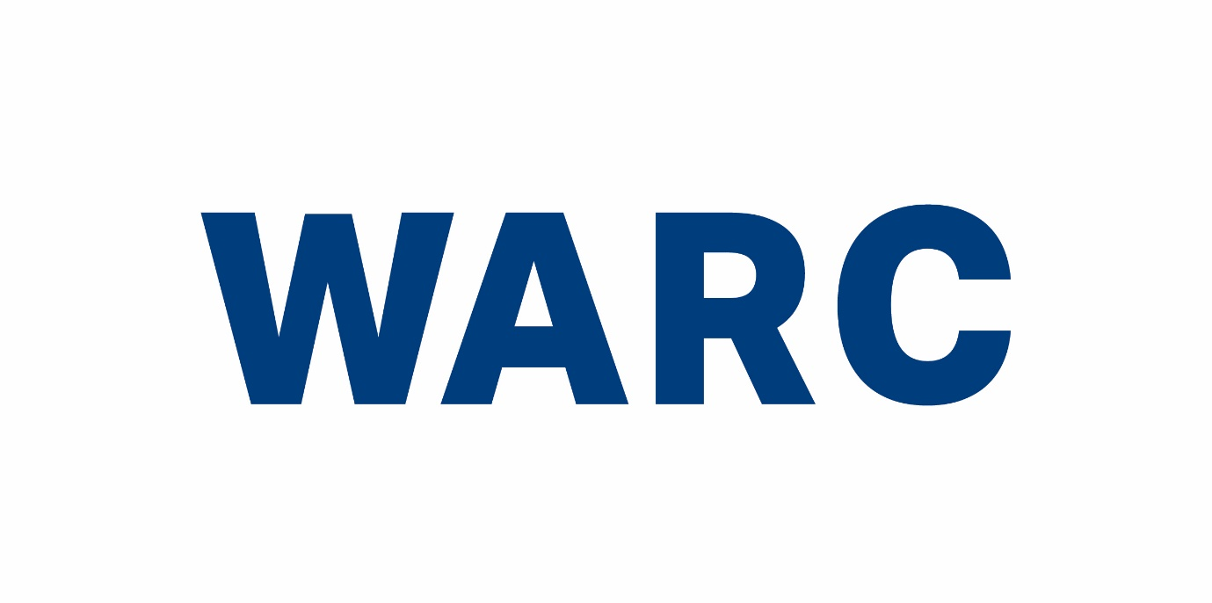Warc.com Case Study Submission
Share your success stories!

Warc is used by marketers and agencies all over the world who are constantly looking at case studies of successful marketing for insight and inspiration.
By sharing case studies of effective marketing with us, your work will feature on our site as an example of best practice for the global advertising industry.
Warc offers evidence and insights for every step of the advertising process, helping brands to remain focused on proven approaches to maximise returns on marketing investments.
You can use this form to submit a case study for inclusion on the site. Please fill in the form with as much detail as possible and send it to lucy.aitken@warc.com.
Alternatively, why not enter your case study into one of our prestigious award schemes? They are free to enter and reward winning entries with cash prizes. More information here.

CAMPAIGN TITLE:
BRAND:
AGENCY:
LAUNCH DATE:
DURATION:
MEDIA USED:
TARGET AUDIENCE:

DETAILS:
Challenge + Business Objectives / What was the background to the campaign and what was the brand hoping to achieve? E.g. launch new product, raise awareness, increase sales)

Insight / What research, either internal or external, helped to inform the strategy? E.g. what did you discover in focus groups or from research reports that steered you towards a solution?

Solution / What was the strategy?

Execution / How was the strategy executed?

Results / Please list as many results as you can that demonstrate the success of this campaign (e.g. sales effectiveness, ROI, brand awareness)

Submitting this form is confirmation that Warc has permission to publish, distribute, edit, summarise and translate the case study and related materials (photos and videos) in perpetuity across all territories and formats. By submitting the form you warrant (ie, promise) and represent that you have obtained all necessary permissions for Warc to publish the submission, and that the submission does not contain anything which is libellous, unlawful, offensive, harmful, or infringes the rights of others or that is a breach of any duty of confidentiality.
You agree to defend, indemnify and hold Warc, its officers, directors and employees harmless from and against any third party claims, alleged claims, demands, losses, damages, liabilities, expenses (including legal costs), judgments, actions, causes of action, made or brought against or incurred by Warc in connection with the submission.

